GREAT TURNING POINT INTERNATIONAL SCHOOL
1ST TERM EXAMINATION 2025/2026 ACADEMIC SESSION
SUBJECT: LETTER WORK CLASS: NURSERY 1
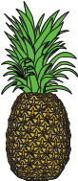
INSTRUCTION: Underline the correct name of these pictures given
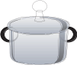
- P as in _____________ (a) body (b) pineapple

- P as in __________ (a) pot (b) pencil

- P as in ______ (a) pear (b) table
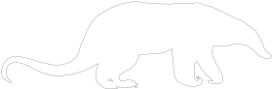
- P as in _________ (a) chair (b) pencil
- P as in __________ (a) rat (b) pig

- Trace these letter Pp

- Circle letters Pp in these boxes
a | p | c | b | q | p | q
k | q | p | b | p | g | u

- Copy down letter Pp
p | p | p | p | p | p

- Trace small letter p

- Letter p is the _________ letter in the alphabet (a) 12 (b) 16
Fill in the correct spelling of the animals

- __________at (b) B (c) R
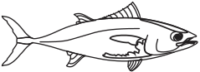
- B ____________ll (a) e (b) t
- Fi_____h (a) b (b) s

GREAT TURNING POINT INTERNATIONAL SCHOOL
1ST TERM EXAMINATION 2025/2026 ACADEMIC SESSION
SUBJECT: NUMBER WORK CLASS: NURSERY 1

INSTRUCTION: Underline the correct name of these pictures given
- =

- =

Match numbers with their pictures
- 1
- 4

- 3

- Circle out number (14) seen inside these boxes
14 | 3 | 11 | 14 | 8 | 4 | 12 | 2 | 1
5 | 14 | 4 | 2 | 0 | 10 | 3 | 11 | 0
8 | 7 | 3 | 1 | 14 | 9 | 9 | 5 | 14
6 | 3 | 14 | 18 | 14 | 8 | 14 | 3 | 4
9 | 5 | 6 | 14 | 18 | 17 | 16 | 14 | 2
 | 14 | 20 | 10 | 9 | 14 | 5 | 1 | 14
17 | 16 | 14 | 11 | 14 | 4 | 8 | 1 | 0

- Count and circle the number of objects
6 8 3

4 3 1

- Count and write the numbers in the box

GREAT TURNING POINT INTERNATIONAL SCHOOL
1ST TERM EXAMINATION 2025/2026 ACADEMIC SESSION
SUBJECT: SOCIAL HABIT CLASS: NURSERY 1
INSTRUCTION: Underline the correct answer from the options given
- The name of my teacher is _____________________
- My teacher is a ___________ (a) man (b) woman
- My teacher is a __________ woman (a) kind (b) wicked
- My teacher teaches us well ___________ (a) yes (b) no
- I always _________ my teacher (a) obey (b) disobey
- Children should not _________ at home (a) pray (b) fight
- Good children do not ____ (a) sweep (b) steal
- The name of my school is _________________
- It is located at ___________________
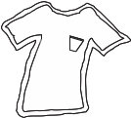
Underline the names of these things that belongs to us

- (a) singlet (b) chair
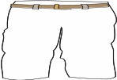
- (a) bell (b) pant


- (a) book (b) brush
GREAT TURNING POINT INTERNATIONAL SCHOOL
1ST TERM EXAMINATION 2025/2026 ACADEMIC SESSION
SUBJECT: VERBAL REASONING CLASS: NURSERY 1
- Circle the capital letter M and U as many as you can see
M | R | M | U | Y
S | U | T | M | A
T | M | W | U | B
V | M | U | S | U

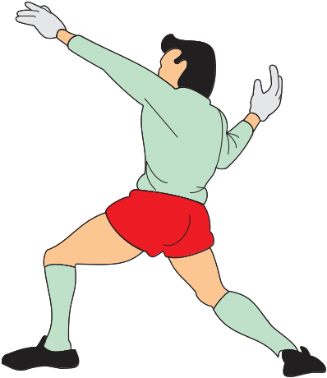
Fill in the missing first letter to the pictures

- ____________ hoe
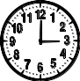
- ______________ap
- __________________lock
Write out the lower case of the alphabet
- E = _____________________________
- B = _____________________________
- D = _____________________________
GREAT TURNING POINT INTERNATIONAL SCHOOL
1ST TERM EXAMINATION 2025/2026 ACADEMIC SESSION
SUBJECT: CRS CLASS: NURSERY 1
INSTRUCTION: Underline the correct answer from the options given
- _____ loves us (a) satan (b) God
- Who died for us in the cross of calvary (a) Jesus (b) mummy
- When we believe in God, God will ____ us (a) dance (b) protect
- _____ is our father (a) God (b) uncle
- __________ is the father of Jesus (a) Joseph (b) John
- ________ visited Mary (a) Jude (b) Angel
- Jesus was born in a __________ (a) hospital (b) manger
- Jesus ______________ his parents (a) obeyed (b) disobeyed
- Jesus was found in the ____________ (a) school (b) temple
- We go to the temple to __________ (a) dance (b) pray
- Mary and Joseph are the parents of _______ (a) Baby Jesus (b) Father
- The manger is a place where ________ sleep (a) manger (b) home
- How many gift did they brought for baby Jesus (a) 4 (b) 3
- Who came to visit Jesus (a) three women (b) three wise men
- _________ put Jesus in Mary’s belly? (a) satan (b) God
- _____ came to the world to save us (a) Jesus (b) mother
GREAT TURNING POINT INTERNATIONAL SCHOOL
1ST TERM EXAMINATION 2025/2026 ACADEMIC SESSION
SUBJECT: HEALTH HABIT CLASS: NURSERY 1
INSTRUCTION: Underline the correct answer from the options given
- I __________ my teeth every day (a) brush (b) comb
- I bathe with ________ and soap (a) chair (b) water
- We must take our bathe twice daily (a) true (b) false
- It is good to eat inside the toilet (a) yes (b) no
- A place where we urinate and defecate is _______ (a) church (b) toilet
- The teeth can be found in the (a) leg (b) mouth
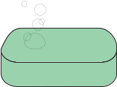
Underline the correct name of these materials used for cleaning the teeth


- (a) toothpaste (b) basket

- (a) tooth pick (b) mouth
- (a) water (b) pencil
- (a) tooth brush (b) chalk
GREAT TURNING POINT INTERNATIONAL SCHOOL
1ST TERM EXAMINATION 2025/2026 ACADEMIC SESSION
SUBJECT: QUANTITATIVE REASONING CLASS: NURSERY 1
Count and match the numbers of these pictures

- 7

- 8

- 5

- 6

1 and 0 = 10
- 3 and 0 = ____________________________
- 4 and 1 = ____________________________
- 4 and 3 = ____________________________
Write out the numbers that comes next
- 10 ________________ 12 ___________ 14 _______________

- = ____________________________

- = ____________________________

GREAT TURNING POINT INTERNATIONAL SCHOOL
1ST TERM EXAMINATION 2025/2026 ACADEMIC SESSION
SUBJECT: NURSERY SCIENCE CLASS: NURSERY 1
INSTRUCTION: Underline the correct answer from the options given
- _________ is a place where we learn how to read and write. (a) house (b) school
- Object found in the school are _____ and ______
- ___________ is use for seeing (a) leg (b) eye
- I ________ my teacher (a) hate (b) love
- Animal in the home are called __________ (a) wild animals (b) domestics animals
___________ and ___________ are domestics animals (a) dog and goat (b) lion and rabbit
- Can we talk with our mouth (a) yes (b) no
Underling the correct name of these object in the classroom
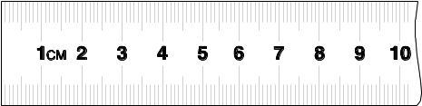
- (a) table (b) ruler
- (a) pen (b) book

- (a) bag (b) bell

GREAT TURNING POINT INTERNATIONAL SCHOOL
1ST TERM EXAMINATION 2025/2026 ACADEMIC SESSION
SUBJECT:LITERATURE CLASS: NURSERY 1
Underline the correct answer
- Ken has a _______(a) cat (b) pig
- It was big and _______(a) red (b) fat
- Who had a cat?(a) ken (b) dan
- Tom had a _____a) Dog (b) goat
- The dog was ______(a) big (b) small
- The cat and the _____ had fun ? (a)dog (b) monkey
- Tom ran in the _____(a) sun (b) box
- Tom said, “I want a ___ (a)toy(b) box”
9. ken said , “it is _____ (a) not ours (b) ours”
10copy down these words
S U N | D O G | C A T

GREAT TURNING POINT INTERNATIONAL SCHOOL
1ST TERM EXAMINATION 2025/2026 ACADEMIC SESSION
SUBJECT: ASUSU IGBO CLASS: NURSERY 1
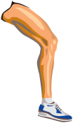
.INSTRUCTION: Zaa ajujundia
- Nke a bu _________________ (a) aka (b) ukwu

- Nke a bu _________________ (a) ire (b) nti



- Nke a bu _________________ (a) olu (b) imi

- Nke a bu _________________ (a) olu (b) ire


- Nke a bu _________________ (a) aka (b) ire


- Six bu _____________ (a) isii (b) abuo
- Five bu _____________ (a) ise(b) otu
- Seven bu _____________ (a) asaa (b) ano
- One bu _____________ (a) otu (b) abuo

- Kachie aha ihe (a) ukwu (b) iko
GREAT TURNING POINT INTERNATIONAL SCHOOL
1ST TERM EXAMINATION 2025/2026 ACADEMIC SESSION
SUBJECT: WRITING SKILLS CLASS: NURSERY 1
INSTRUCTION: copy down these words
FISH | BALL
Copy down of numbers (1-10)
1 | 2 | 3 | 4 | 5 | 6 | 7 | 8 | 9 | 10
Copy down letter Xx inside these boxes

GREAT TURNING POINT INTERNATIONAL SCHOOL
1ST TERM EXAMINATION 2025/2026 ACADEMIC SESSION
SUBJECT: CULTURAL AND CREATIVE ART CLASS: NURSERY 1
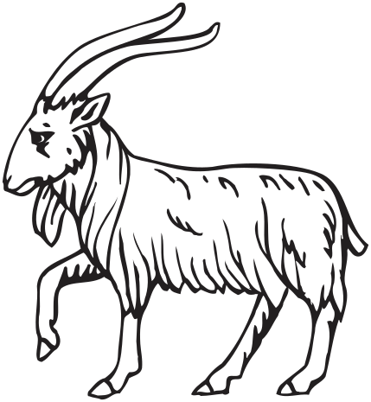
Colouring of a domestic animals

This is a Sheep.
Colour it red

Copy down
P | I | G
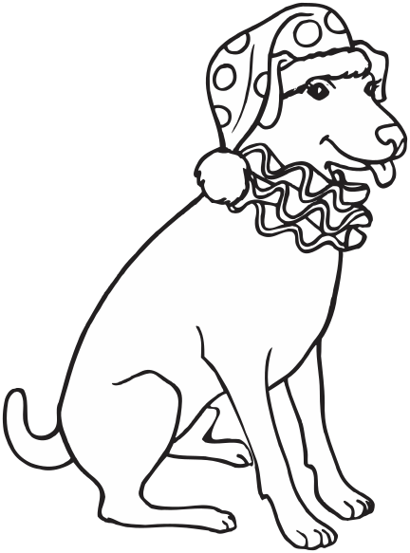

D | O | G

This is a Dog.
Colour it red

